Rockstar Icons Requirement
---------------------------------------

1. https://rockstar.vibrantick.org/

-> What we offer
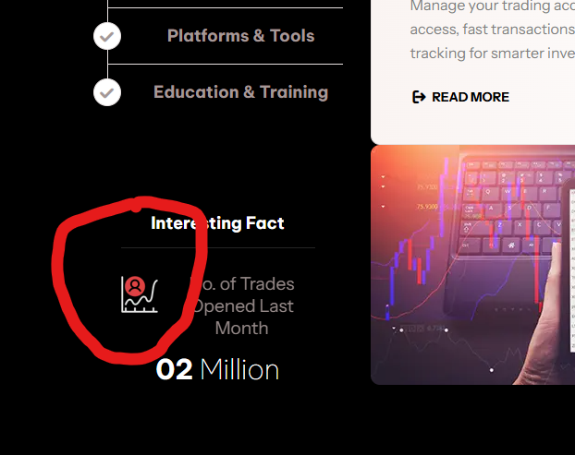
-> key highlights
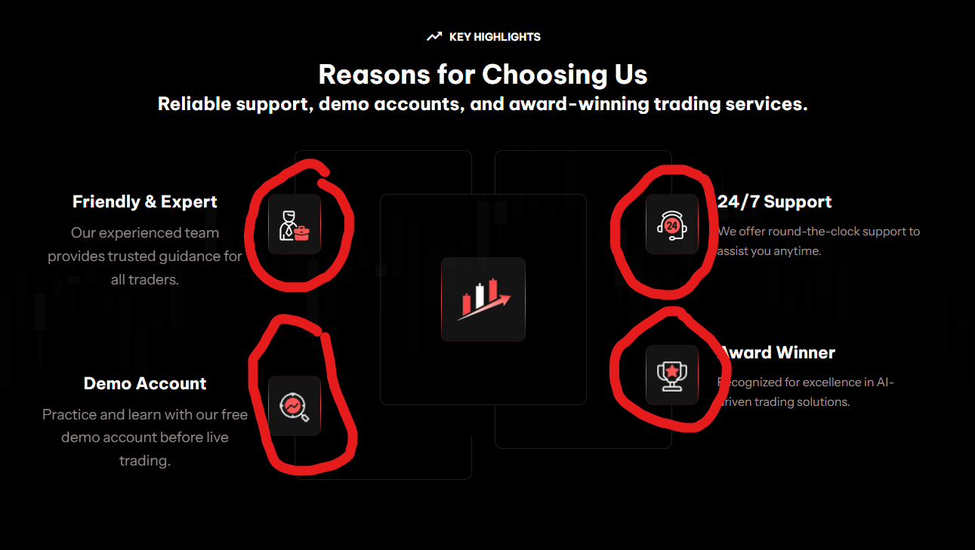
-> Faq

-> Testimonials
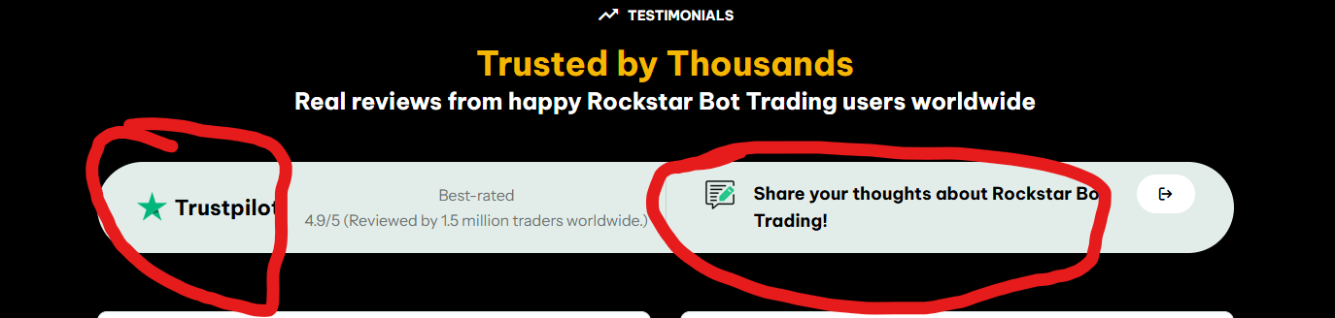
2. https://rockstar.vibrantick.org/about-us

-> Stats (24 hours , 02 million etc)
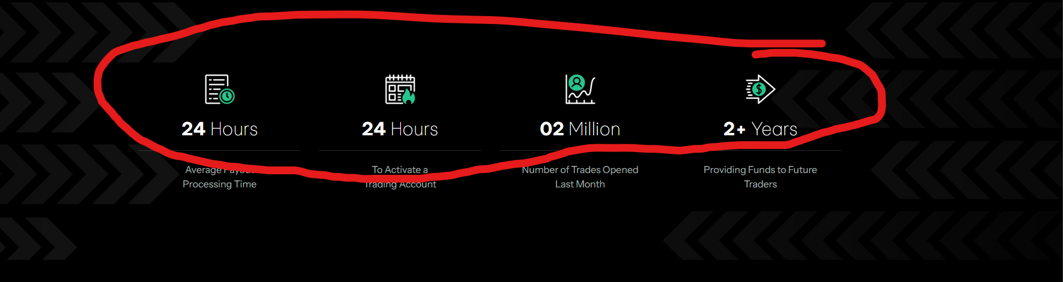
-> Statements
-> Our mission (mountain shape)
-> Our vision (mountain shape)
-> Icon on our mission
-> Icon on our vision
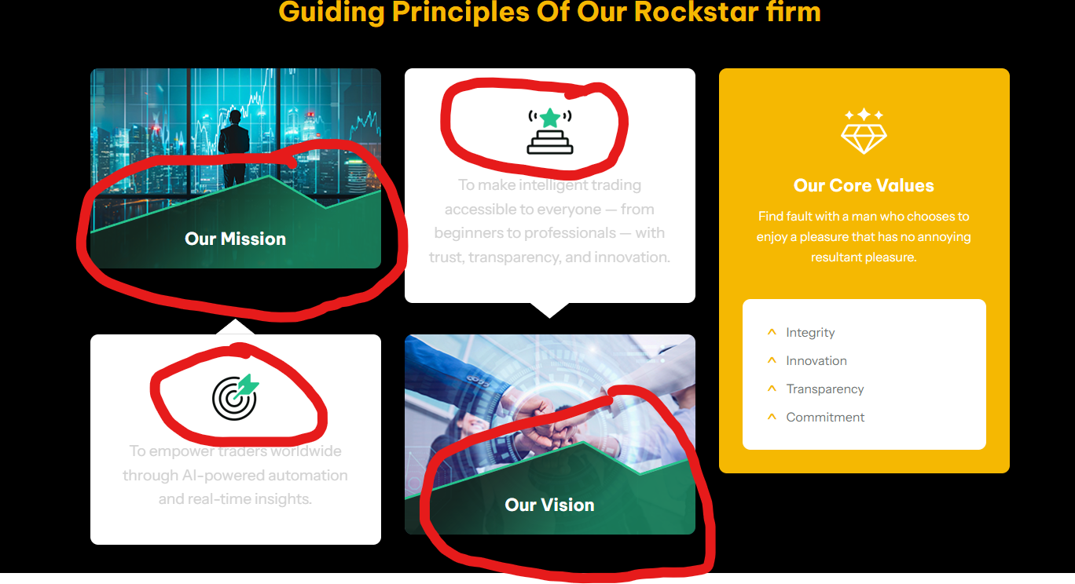

3. https://rockstar.vibrantick.org/contact-us

-> Contact us icons
-> Say hi hello
